INPUT : There are a total of 1339 available data sets.

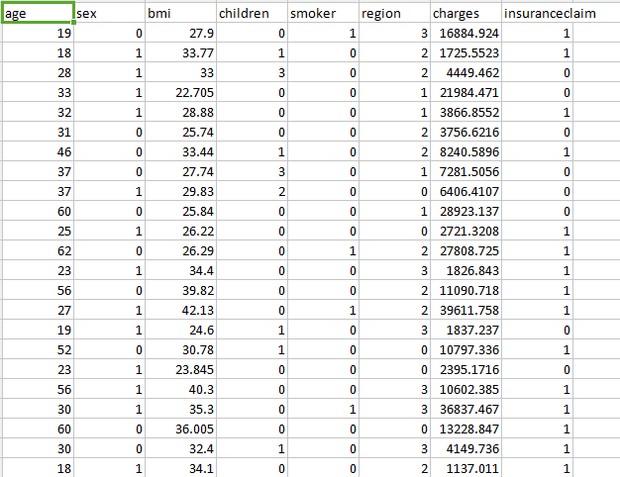

CLEANED DATA:

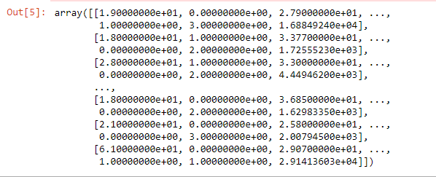

OUTPUT:

PIE CHART

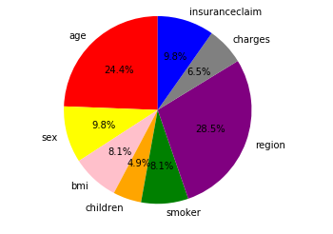

DECISION TREE

It is done using unsupervised learning.

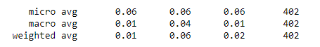

HISTOGRAM

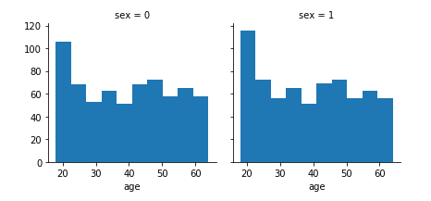

The left side of the diagram represents the female and the right side of the diagram represents the male.

x-axis represents the age and y axis represents the number in hundreds.